**Chef-Installation**

**Requrements :**

Initially needed **three** Machines like vagrant10(192.168.33.10),vagrant11(192.168.33.11),vagrant12 (192.168.33.12)

After installing the Three machines .

check the Memory in vagarnt10(192.168.33.10)machine for that login to machine run the following command

#free -m

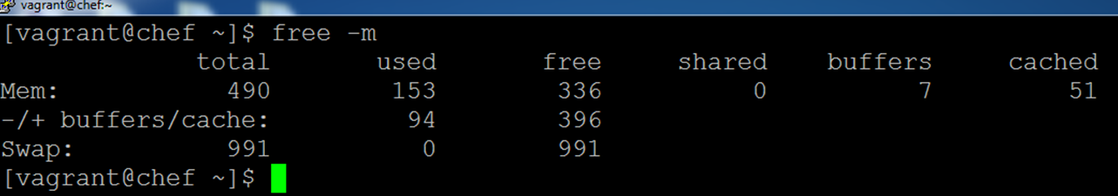

Initially memory is **490MB** But we need to increase the memory to **1 GB(996MB)** for chef configuration

For this we need to do following..

In the 192.168.33.10 vagrant folder we have a Vagrantfile. Edit that file and to do changes in Virtual box Memory Lines..

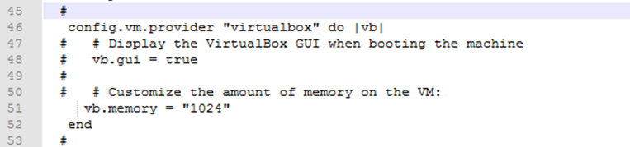

After editing save this file.

Go to Vagrant folder and open cmd prompt there only(Below run **cmd** Where Text is hilighted)

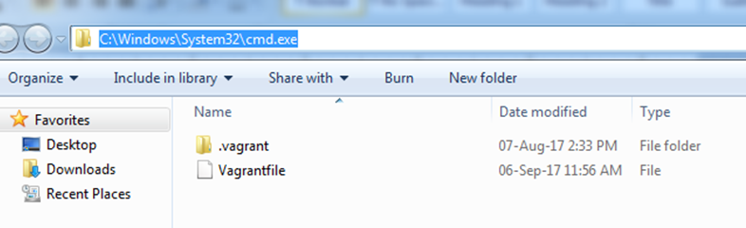we need to reload the vagrant.. 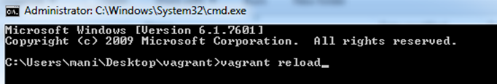

After reloading Login to 192.168.33.10 machine and check the memory

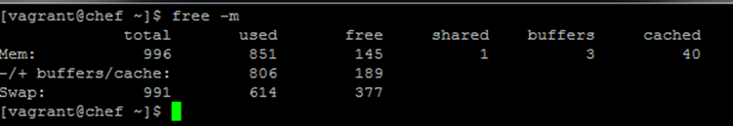

**change the hostname: by using editing the following config. files**

***Do in two machines(192.168.33.10 & 192.168.33.11)***

Edit two files /etc/hosts & /etc/sysconfig/network

**#vi /etc/hosts**

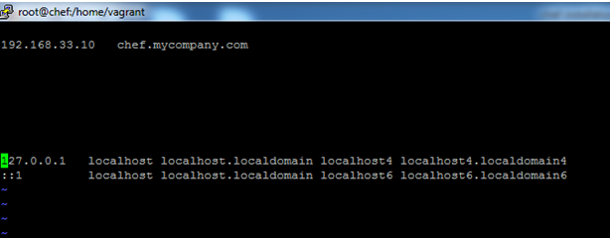

**# vi /etc/sysconfig/network**

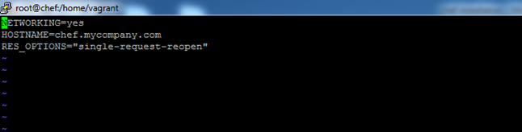

**Edit only one file /etc/hosts in 192.168.33.12 machine**

**#vi /etc/hosts**



After changing the hostname then ***reboot*** all the machines

**#reboot (Run this command all three machines)**

**In 192.168.33.10 Virtual Machine(Chef-server,Chef-Manage rpms)**

Login to this machine and switch the user from vagrant to root

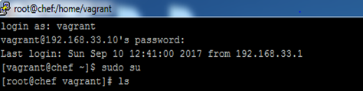

First Copy the chef-server-core,chef-manage rpms to this virtual machine by using **WinScp** Tool

Install the two rpms & Reconfigure

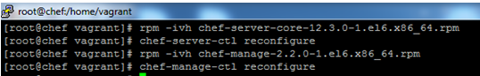

Create the Chef User and Password by using following command



***If you get 'user' already existed. Then change the username , mailid and exicute the command***

After creating the account..Go to Browser and type the 192.168.33.10...then it will give first time only ***this is not secure connection***

In that page has *Advanced---->click on Proceed 192.168.33.10 connection*

After this it will give like

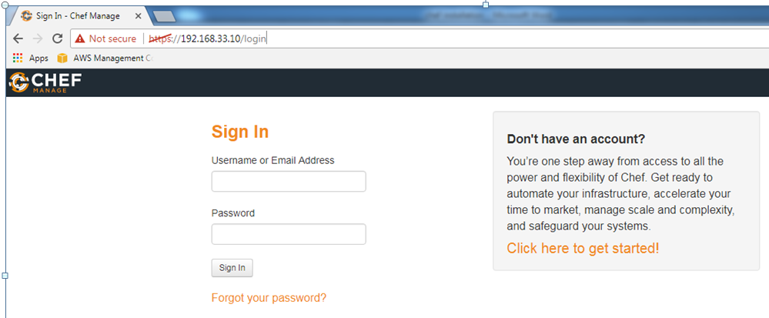

sign in as your credentials.. and create organization

Then create organization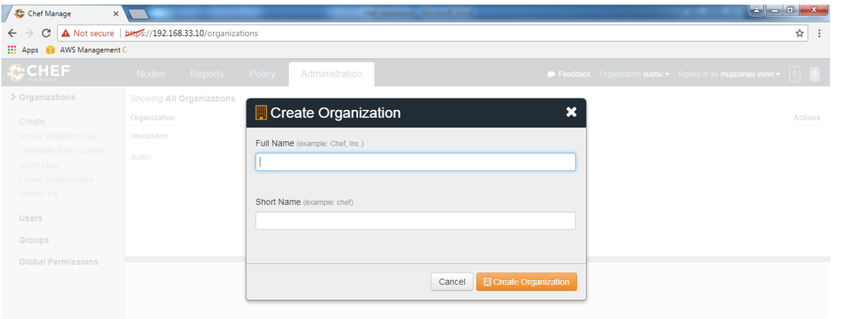

After creating the organization...Please down load the **starter kit , it is downloaded as chef-starter .zip file**

**Extract** the Chef-starter Zip file(c***hef-repo*** keep it in safe place)

After rebooting..

Now copy the chef-repo and chefdk rpm to 192.168.33.11 machine by using WinScp tool

Install the rpm file..

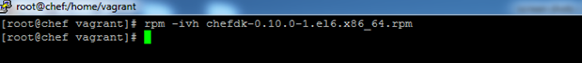

**Caution:**  Please verify where you are executing/Run the commands (i.e. Exact Path Location)

Go to chef-repo directory

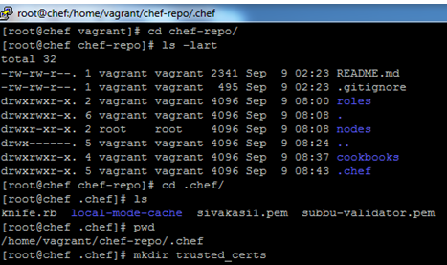

Now copy the chef.mycompany.com.crt ssl certification file from 192.168.33.10 to 192.168.33.11 by using scp command

**In the 192.168.33.10 Machine**

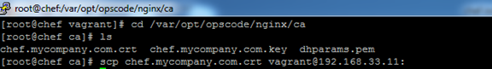

**Now in the 192.168.33.11 Machine**

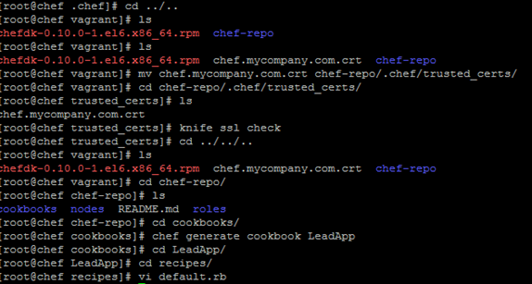

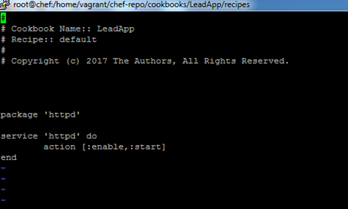

After save & exit of above file then run following command...







After exicuting above command successfully...

**Go to 192.168.33.12 Machine**

check the httpd service..

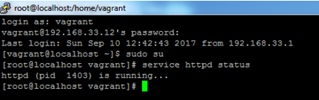

**Then go to browser and give 192.168.33.12**

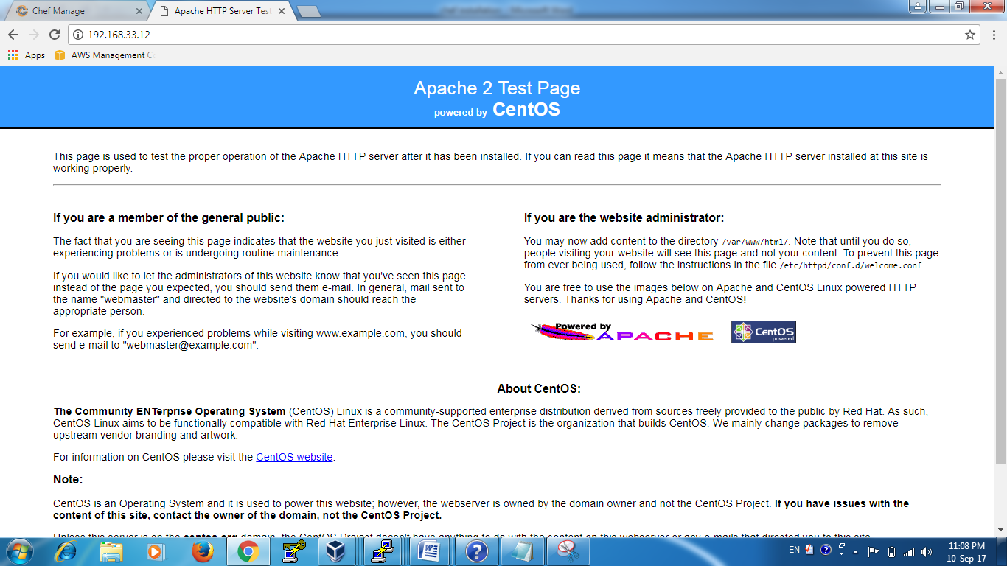

~~~Thank You For …~~~

………………………………………**Ramanji** **Reddy(Sir)**…………………………..

…………………….Anusekhar Reddy……………